NIS RETURN TO PRACTICE GUIDELINES
North Iowa Splash swimmers, coaches, board members, parents, family and volunteers will adhere to all Federal, State, Local, CDC, USA Swimming and facility guidelines during practice. Additional protocol is outlined below:
Swim Team
- Swimmers must take their temperature prior to attending practice. Temps over 100 may not practice until fever free, without use of medication, and not show any other symptoms for a period of 72 hours. Coaches may take temperature of any athlete at the beginning of practice, if available, but it is the primary responsibility of swimmers to ensure they do not have a fever when attending practice.
- If your swimmer is able to answer yes to any of the below questions, they will not be allowed into practice unless fever and symptom free for 72 hours.
  - Have you or someone in your household been exposed to Covid-19 in the last 14 days?
  - Have you experienced any of these symptoms in the last 14 days? Fever, shortness or breath, cough, loss of taste/smell, headache, soar throat, nausea, vomiting, or diarrhea.
- Swimmers should shower prior to coming to practice.
- Other than caps and googles, no equipment will be used at this time.
- Participants must bring own water bottle to practice and not sharing will be allowed.
- Swim distance should be 6’ or greater
- Max participant in a lane will be 4-5-4 (see illustration below)
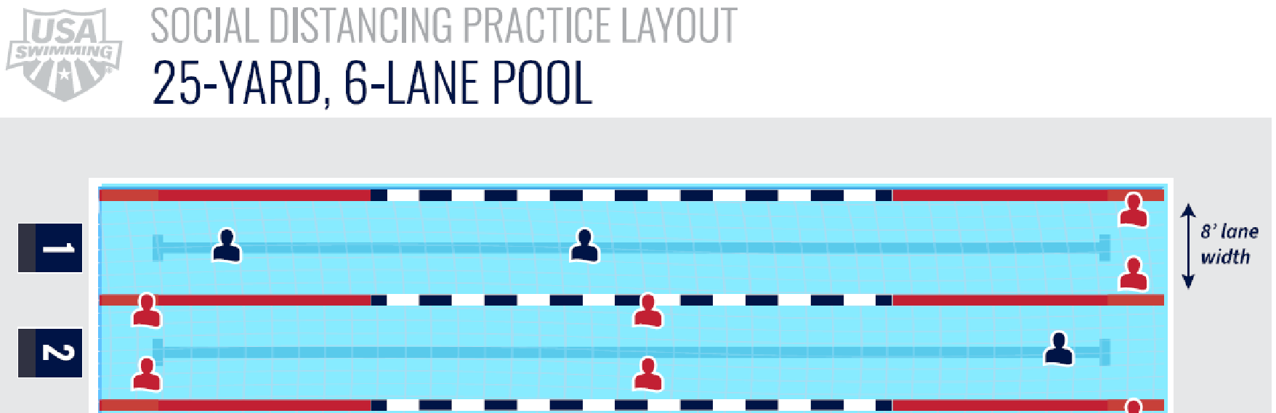

Drop off/Pick Up
- Swimmers 14 and under may have a parent or guardian walk them into practice and come to into the pool area to pick them up arriving no more than 10 minutes before practice ends.
- Parents or guardians of swimmers 14 should drop off and pick up swimmers in the designated drop off/pick up area of the facility.
- Swimmers are asked to leave promptly after practice and not to congregate. Please maintain a 5 feet social distancing while getting into vehicles.

General Guidelines
- No spitting, or touching each other intentionally (including high fives)
- Stay 6 feet apart whenever possible
- It is more important than ever that all swimmers follow coaches’ instructions. Coaches will give clear directions and warnings once. If there is a continued issue with a swimmer they will be asked to leave.
- Swimmers should wear their suits too and from practice. A single bag of dry items can be stored on the pool deck and spaced 6 feet apart from other swimmer’s items.
- Please limit the use of restrooms/locker rooms if they are available. Please plan ahead as restrooms may not be available at some facilities.
- If a swimmer feels unwell with a fever or symptoms related to Covid-19, is exposed to Covid-19, or test positive to Covi-19. Please notify the club at our email address of northiowasplash@gmail.com.
- Athletes who have been diagnosed with or are suspected to have Covid-19 must see a physician and be cleared before returning to practice.

